A Study on Optimal Flight Path Algorithm of Ultra-Light flight devices for Dynamic Information Observation in Urban Areas

Sung Hong Ki¹, Chong Kyu Soo¹ and Youn Jun Hee*²
¹Korea Institute of Civil Engineering and Building Technology
10223, 283 Goyang-daero, Ilsanseo-gu, Goyang-si, Gyeonggi-do
Email: sunghongki@kict.re.kr
Email: ksc@kict.re.kr
Email: younj@kict.re.kr

KEY WORDS: Ultra-Light flight device, Dynamic information, Flight path, Algorithm, Urban areas

ABSTRACT: In order to observe dynamic information such as vehicles, pedestrians, and PM(Personal Mobility) using ultra-light flight devices in urban areas, it is essential to design an optimal flight path that comprehensively considers flight safety, accuracy of observation data, and flight efficiency. Accordingly, this paper proposes an optimal flight path algorithm for ultra-light flight devices for observing dynamic information in urban areas. For this purpose, flight strategies and limiting conditions in urban areas were reviewed. The optimal flight path algorithm was designed by dividing into a z-axis path that determines the flight altitude and an x- and y-axis path that determines the flight path in a two-dimensional plane.

Introduction
Recently, demand for providing information and services of dynamic information such as vehicles, PM(Personal Mobility), and pedestrians on urban roads is increasing. In order to provide convergence analysis and service on dynamic information in a wide area, dynamic information observation in the air should be performed. In the observation of dynamic information using an ultra-light flight devices in urban areas, it is essential to design an optimal flight path considering flight safety, efficiency, and accuracy of observation data. Accordingly, in this paper, an optimal flight path algorithm for ultra-light flight devices for dynamic information observation in urban areas is proposed.

Goal and strategy of flight
Research related to the development of optimal flight paths and algorithms for drones was conducted. A study on building a drone safety flight map was conducted. A 3D grid-based map was constructed using high-precision spatial information, and a safe flight path algorithm for drones was proposed. The effectiveness of the proposed technology was confirmed through simulation. A study was conducted to propose a two-dimensional optimal flight path derivation technology for flight safety. In this study, dynamic and static obstacles on the ground were distinguished to derive the flight path. The optimal 2D drone flight path was calculated using floating population density calculations and building location maps. Research has been conducted on the development of flight avoidance technology that can take into account hazardous areas. The proposed algorithm is capable of finding a route that can appropriately avoid a risk area consisting of several stages. It was confirmed that the performance of the proposed algorithm is superior to the existing algorithm.
In this paper, first of all, the flight strategy was established and the flight limiting conditions were reviewed for the design of the optimal flight path algorithm of the ultra-light aircraft in urban areas. Flight strategies for dynamic information observation in urban areas were classified into three types. The first strategy is flight in which all road lanes can be observed in order to efficiently observe dynamic information such as vehicles and pedestrians around the urban roads. The second strategy is to ensure the accuracy and high resolution of dynamic information observation data by ultra-light flight devices at the lowest possible altitude. The third strategy is avoidance of high-risk areas, such as schools and parks, where there is a high risk of accidents in the event of a flight devices crash due to dense crowds of people. Flight restrictions conditions include restrictions on flight areas over roads, flight altitude restrictions of 150 meters, and avoidance of dangerous areas.

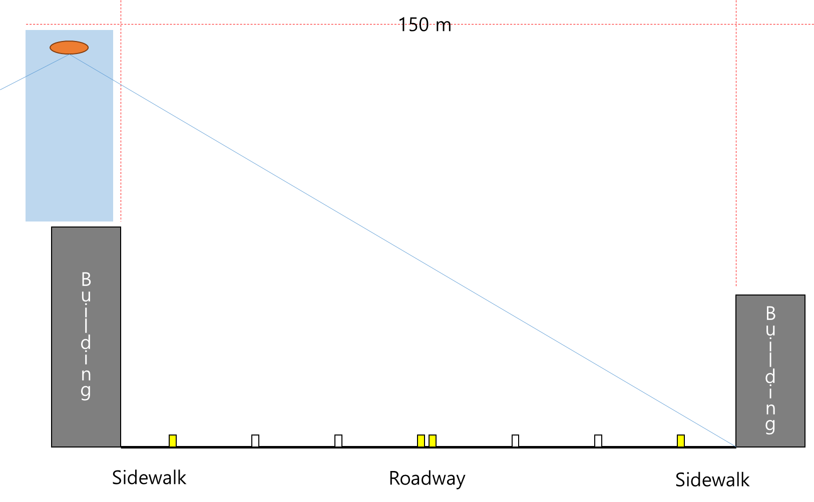
Figure 1. Goals of flight in urban areas.

Optimal flight path algorithm in urban areas
The optimal flight path algorithm of the ultra-light flight devices in urban areas was designed by dividing into the z-axis path that determines the flight altitude and the x, y-axis path that determines the flight path on a two-dimensional plane. The z-axis path algorithm consisted of four steps: altitude setting according to the number of road lanes, minimum safe altitude setting in urban areas, safe altitude setting to avoid high-rise buildings, and flight limit altitude setting. The x, y-axis path algorithm was composed of three steps: path boundary point setting, dangerous area recognition, and avoidance and reconnection path setting. The optimal flight path algorithm in urban areas proposed in this paper can create a 3-dimensional flight path only when all conditions are satisfied for the x, y, and z axes.

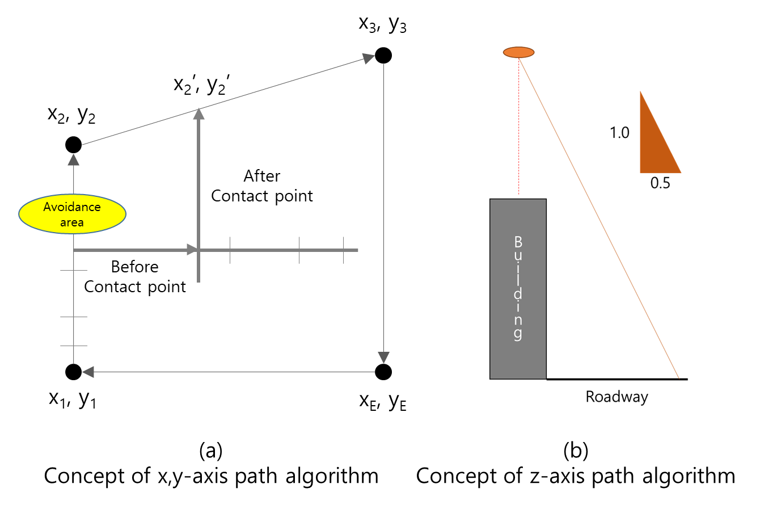
Figure 2. Concept of path algorithms.

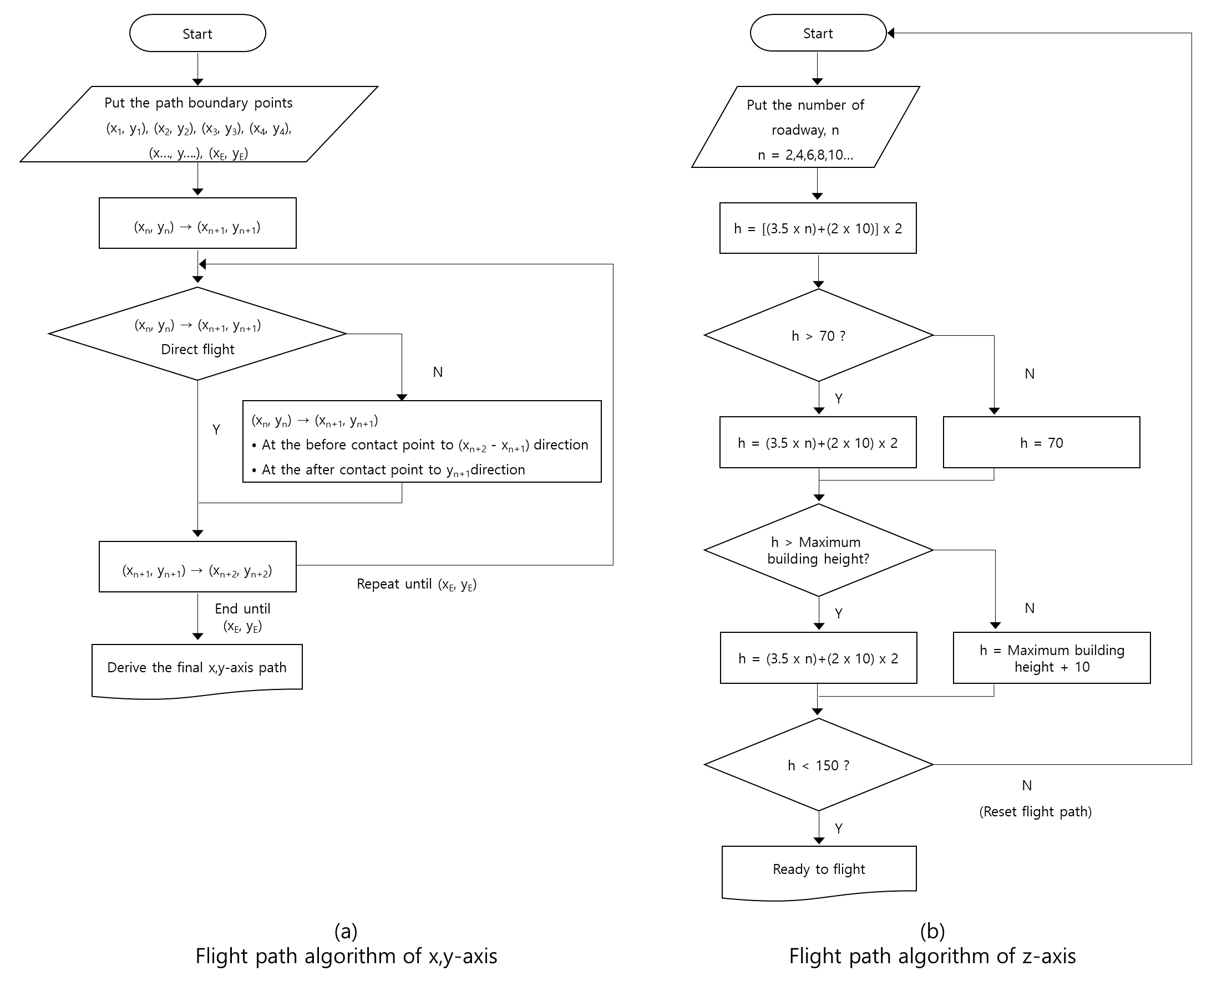
Figure 3. Flight path algorithms.

Expected effects and future research
The proposed optimal flight path algorithm for ultra-light flight devices for dynamic information observation in urban areas can secure flight safety, observation efficiency, and high resolution of observation data. An effect verification study through comparative analysis of the existing method and the proposed flight path algorithm in the actual flight path should be additionally conducted.

Acknowledgements
The research was supported by the ‘Development of Fixed/Moving Platform Based Dynamic Thematic Map Generation Technology for Next Generation Digital Land Information Construction(RS-2022-001432782).

References
Hong, K.H., Won, J.H., and Park, S.H. (2021), A Study on the Construction of a Drone Safety Flight Map and The Flight Path Search Algorithm, Journal of Korea Multimedia Society. 24(11), pp. 1538-1551.
Kim, J.E., and Youn, J.H. (2022), Derivation of Drone Optimal 2-dimensional Flight Path based on Ground Suitability for Flying Safety, Journal of the Korean Society of Surveying, Geodesy, Photogrammetry and Cartography. 40(6), pp. 603-612.
Kim, S.H., and Shin, J.H. (2021), Development of a Modified Jump Point Search (MJPS) Method for Considering Danger Zones, Journal of Institute of Control, Robotics and Systems. 27(10), pp. 754-761.

